Window Shopper – Additional Search Methods

In addition to using a simple keyword search, there are other options for searching in Window Shopper.

Step | Do This:
1 | There are several additional ways to shop in Window Shopper. In the example shown, we will do a Category search for “paper". To do a Category search, click the drop-down arrow to select the desired category, type the item description into the Search field, and click the Go button.  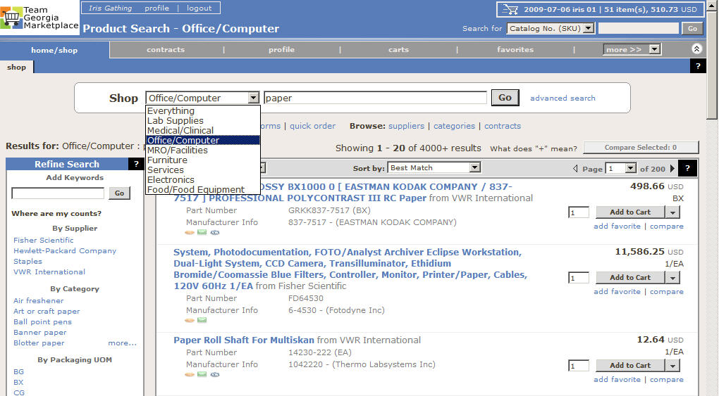
2 | In this example, the search results for paper show over 4000 results.  - Add Keywords  - By Supplier  - By Category  - By Packaging UOM  In the example shown, we will narrow the search using the By Supplier (Staples) option.  To use the By Supplier feature, click on the appropriate Supplier name in the Refine and Filter Search box.

3 | In the example shown, narrowing the search by Supplier did not change the number of results.  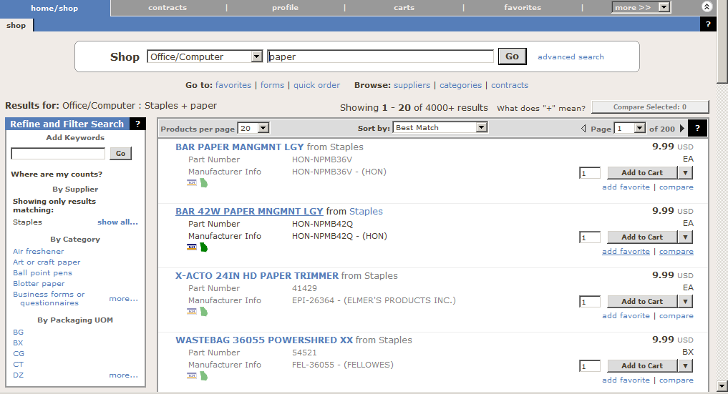
4 | To narrow the search further, you may filter by Category. To expand the Category search list, click the “more…” link and scroll down the list to find the proper category. In the example shown, we scrolled down to find “multipurpose paper”  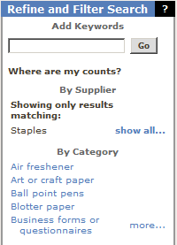

5 | In the example shown, using the Category filter for multipurpose paper narrowed the search results to 390.  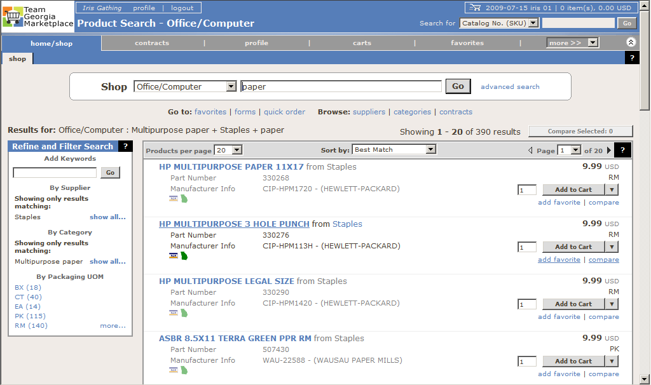
6 | You may further narrow the search using the Packaging UOM filter. Note that the UOM filter shows the number of results for each packaging measurement. In the example shown, selecting the “bx” measure narrowed the results to 18.  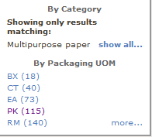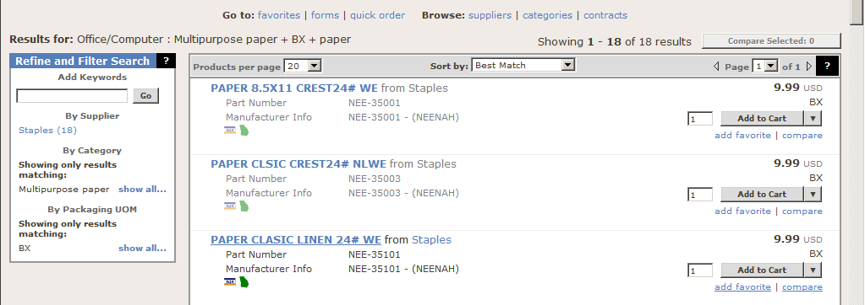
7 | Once you have reached the desired results, add the quantity, click the Add to Cart button and place the order to continue the requisition.
8 | End of Procedure

